**Expense Tracker Application Phase - 3: Data Modeling and UI Configuration**

**Objective:** To construct the core data architecture for the Expense Tracker application. This phase covers the creation of custom objects, fields, and relationships, as well as the configuration of user interface elements like page layouts and record types.

**Step 1: Create the 'Expense' Custom Object**

First, we will create the central object that will store all expense records.

1. **Navigate:** Go to **Setup → Object Manager**, then click **Create → Custom Object**.
2. **Enter Details:**
   * **Label:** Expense
   * **Plural Label:** Expenses
   * **Object Name:** Expense (The API name will automatically become Expense__c)
3. **Configure Record Name:**
   * **Data Type:** Select **Auto Number**.
   * **Display Format:** EXP-{0000}
   * **Starting Number:** 1
   * **Purpose:** This creates a unique, user-friendly identifier for every expense record (e.g., EXP-0001).
4. **Save** the new object.

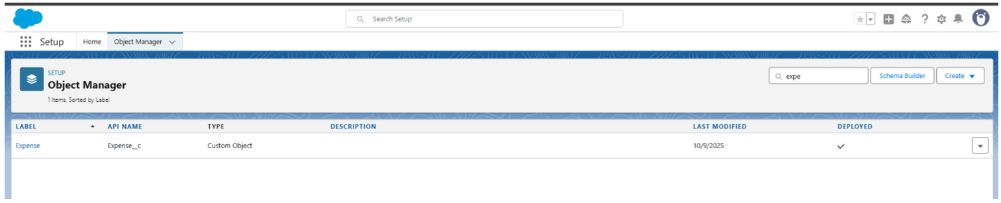

**Step 2: Add Custom Fields to the 'Expense' Object**

Next, we will add the necessary fields to capture expense details.

1. **Navigate:** From the **Object Manager**, select **Expense**, then go to **Fields & Relationships** and click **New**.
2. **Create the following fields:**

|  |  |  |
| --- | --- | --- |
| Field Label | Data Type | Details |
| **Amount** | Currency | Mark this field as **Required**. |
| **Expense Date** | Date | Mark this field as **Required**. |
| **Category** | Picklist | Enter the values: Travel, Food, Other. |
| **Description** | Text Area | This field is optional for additional notes. |
| **Approval Status** | Picklist | Enter the values: Pending, Approved, Rejected. |
| **Employee** | Lookup(User) | Mark this field as **Required**. This links the expense to a user record. |
| **Manager Approval** | Lookup(User) | This optional field can be used later for approval processes. |

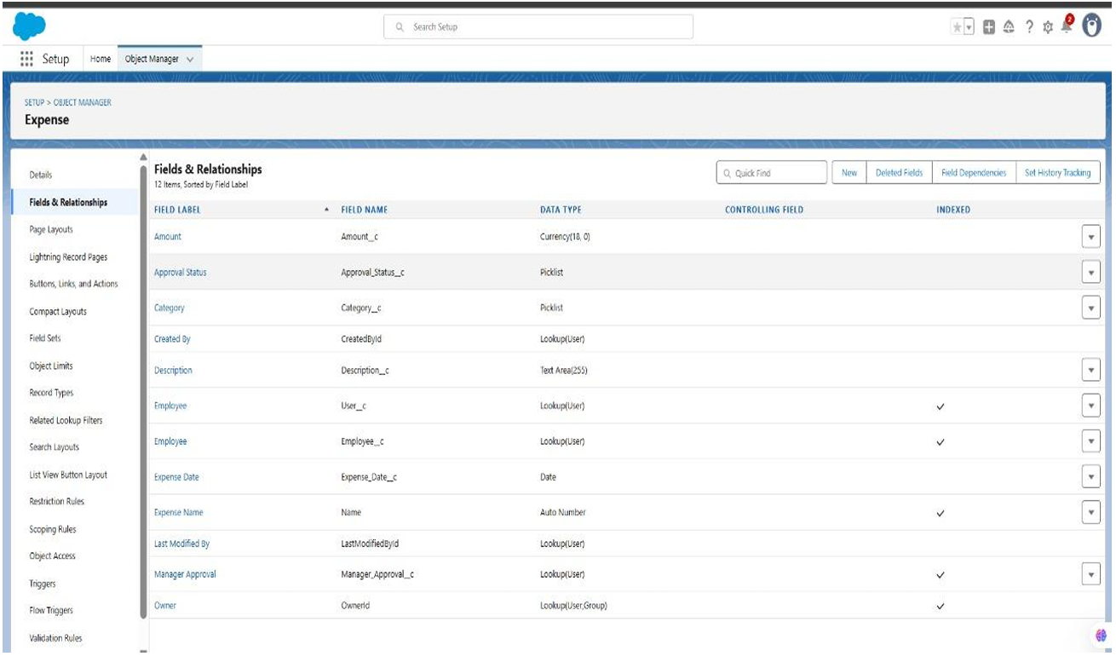

**Step 3: Configure Page and Compact Layouts**

Now, we will organize the fields on the user interface for optimal usability.

1. **Page Layout:**
   * **Navigate:** From the **Expense** object page, go to **Page Layouts** and **Edit** the default layout.
   * **Action:** Drag and drop the following fields onto the layout in a logical order: Expense Number, Amount, Expense Date, Category, Employee, Description, and Approval Status.
   * **Save** the layout.
2. **Compact Layout:**
   * **Navigate:** From the **Expense** object page, go to **Compact Layouts** and click **New**.
   * **Action:** Add the following key fields: Expense Number, Amount, Expense Date, and Approval Status.
   * **Save** the layout and then use **Compact Layout Assignment** to assign it to all profiles.
   * **Purpose:** The compact layout controls which fields are displayed in highlights, mobile views, and list views for quick reference.

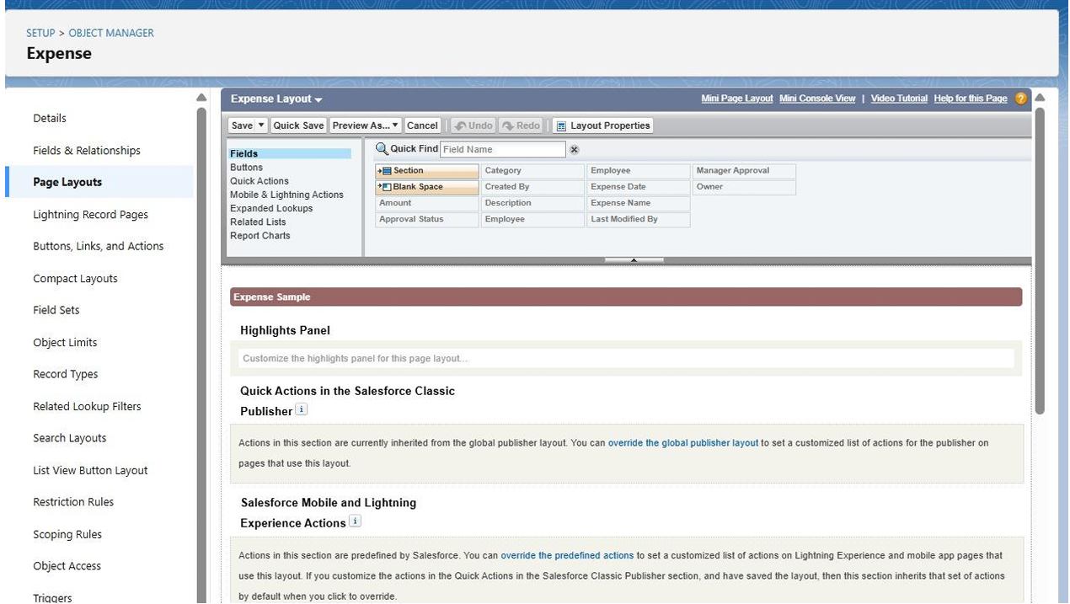

**Step 4: (Optional) Implement Record Types**

Record types allow for different business processes and page layouts for various kinds of expenses.

1. **Navigate:** From the **Expense** object page, go to **Record Types** and click **New**.
2. **Create Record Types:** Set up distinct record types based on the Category picklist, such as Travel Expense, Food Expense, and Other Expense.
3. **Assign:** Make these record types available to the Expense Employee Profile and Manager/Admin profiles. You can assign the same page layout to all for now.

**Step 5: Verify the Data Model with Schema Builder**

Use the Schema Builder to visually confirm the relationship you created.

1. **Navigate:** Go to **Setup → Schema Builder**.
2. **Action:** In the object list, find and select the Expense and User objects to display them on the canvas.
3. **Verify:** Confirm that a lookup relationship line connects the Expense object (via the Employee field) to the User object.

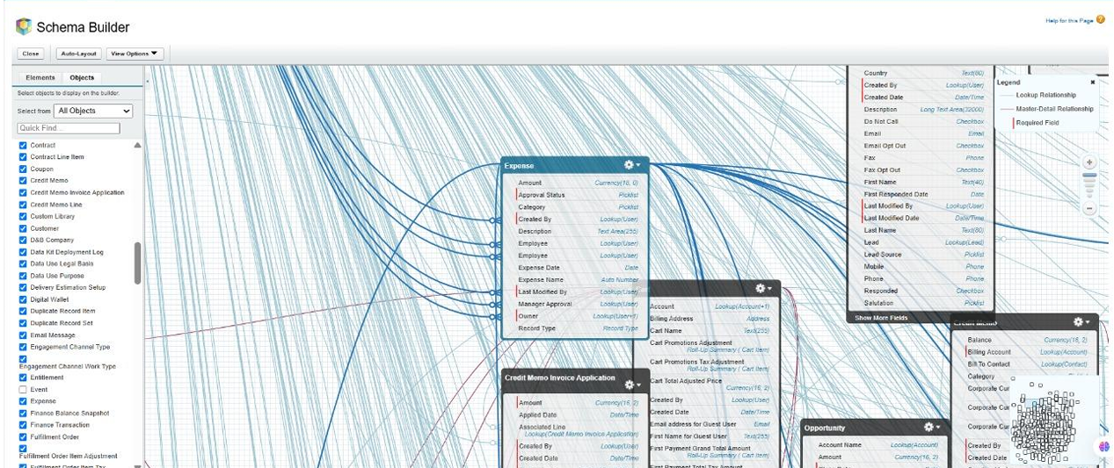

**Step 6: Finalize Security and Access Settings**

Ensure the correct profiles can see and edit the new fields and object.

1. **Field-Level Security (FLS):**
   * **Navigate:** Go to **Setup → Profiles → Expense Employee Profile**.
   * **Action:** Under **Object Settings → Expense**, ensure users have **Read**, **Create**, and **Edit** access. Verify that all the new fields are visible. Repeat this process for the Manager/Admin profile, granting them appropriate access.
2. **Save** any changes to the profiles.

**Step 7: Conduct a Validation Test**

Finally, test the configuration to ensure everything works as expected.

1. **Log in as the Employee user.** Navigate to the Expenses tab and create a new expense record. Confirm you can fill out all fields and save the record.
2. **Log in as the Manager user.** Verify that you can view the record created by the employee.
3. **Negative Test:** Log in as a different employee user (if one exists) and confirm that they **cannot** see the expense record created by the first employee, validating your sharing settings.

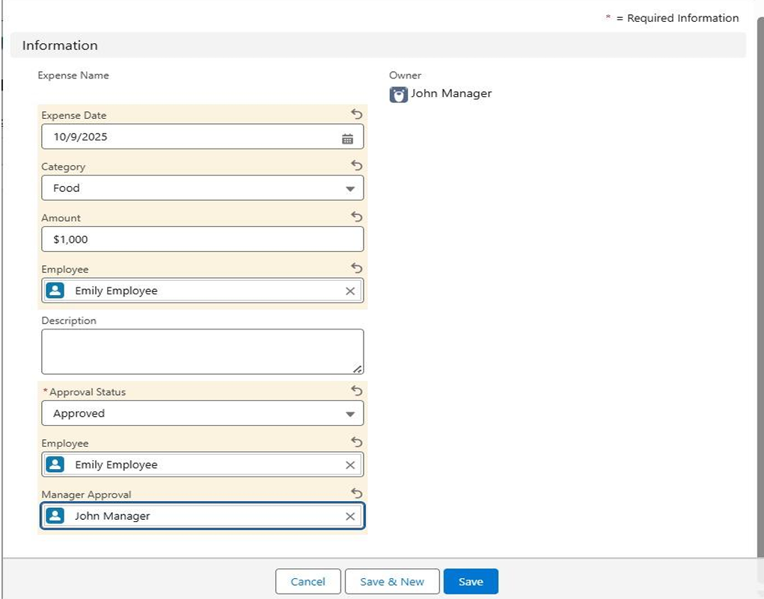

**Phase 3 Completion:** The data model for the Expense object is now established, user interfaces are configured, and security settings have been verified. The application is ready for the next phase of development, such as building automation and reports.